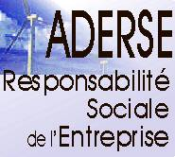

4th ADERSE Conference

Organized in partnership with the
Society for Business Ethics (SBE) and the
International Society of Business, Economics and Ethics (ISBEE)

Hosted by Bordeaux Ecole de Management, France

October 26-27th, 2006

Call for Papers

Advances in Research and Education on CSR

“Is There a Responsibility of Business Schools

to Promote Corporate Social Responsibility?”

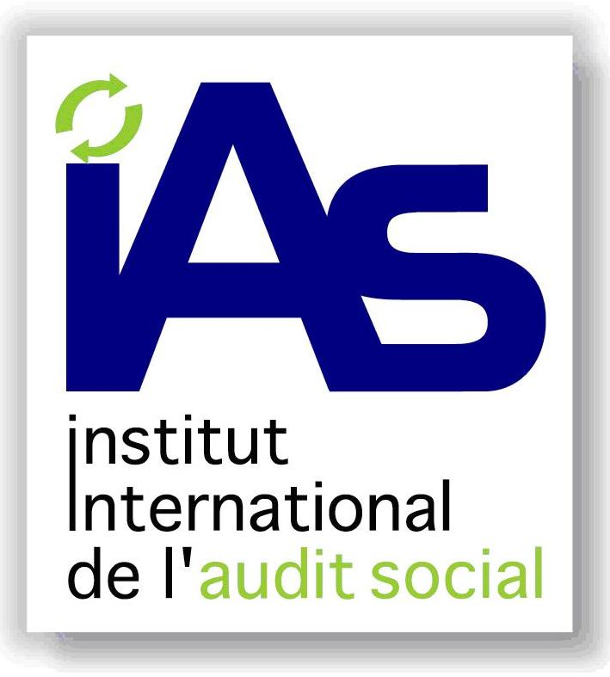



ADERSE was created in 2002 with the mission of developing education and research in the field of CSR and Business Ethics in France. The first ADERSE Conference was held in 2003 in Paris, the second in 2004 in Toulouse, and the third Conference, co-sponsored by ISEOR and the SIM Division of the Academy of Management, took place in Lyon in October 2005.

ADERSE is pleased to invite submissions to its 4th Conference, which will concentrate on the main theme indicated above, in three languages: English, French and Spanish. The purpose of this Conference is to facilitate a constructive dialogue between professors and researchers working worldwide on business education and CSR-related issues.

Submissions can range over the following topics:

I. Research on CSR

Integrating CSR into the various areas of management

- How to embed corporate responsibility in strategy, marketing, finance, HRM, accounting and control, supply chain and operations management?
- Measurement and reporting issues related to CSR.
- Taking into account norms, principles and labels dealing with CSR.

Theoretical, disciplinary and cultural approaches of CSR

- Theoretical frameworks of CSR: stakeholder theory, social contracts theory, institutional theory, sustainable development theory…
- Interdisciplinary perspectives on CSR: law, economics, sociology…
- Corporate social responsibility and its understanding in different cultures.

Corporate social responsibility and organizational dynamics

- Elaboration and implementation of an ethical policy, employee training and motivation, internal communication, organizational learning.
- Development of partnerships between companies and other actors: associations, NGOs, local authorities, international institutions…
- Employees working for the community, involvement in external structures.

Cross-cultural dialogue and the search for a global ethics

- The problematic elaboration of a set of shared ethical values on the global marketplace.
- Questioning and rethinking the purpose of corporations worldwide is a fundamental issue for management education. How should this theme be handled?
- Could business schools foster a dialogue on that issue with their foreign counterparts?

II. CSR Education

Educational content of CSR programs

- Curriculum examples, syllabi, readings, dialogue starters related to CSR teaching.
- Pedagogical approaches utilized in CSR education: case studies, role-playing, personal implication, students’ projects, etc.
- Demonstrations and workshops on CSR teaching software and methods.
- How to assess students’ appropriation of the responsibility dimension

International comparisons of CSR education

- Teaching business ethics, CSR, and sustainable development in various countries: comparative perspectives.
- Development of the teaching of business ethics in the U.S. and its evolution towards CSR and corporate citizenship.
- Differences in CSR teaching methods depending on course design.

Mainstreaming CSR in business curricula

- Should CSR courses be made compulsory and why?
- Stand-alone courses vs. integration, or both.
- How to permeate the ethical concern and CSR-related issues through traditional management disciplines (strategy, organizational behavior, finance, marketing, accounting and control, operations management…)

Institutional aspects

- Institutionalization of CSR (degrees, chairs, certifications, specialized departments, etc.)
- Accreditation criteria for courses on ethics and the role of accreditation bodies.
- CSR as a means of differentiation and strategic positioning: some pioneering business schools have already chosen to differentiate themselves along this line. To what extent can they lead the others to follow this orientation?

What are the responsibilities of business schools in the world today?

- How can they be defined in relation to the process of globalization and its consequences?
- Changing the mindsets in business schools: what are the best levers and strategies?
Should deans, professors and students be selected according to their ethical sensitivity?
- How to find a balance between the development of students’ managerial knowledge and their societal and environmental awareness?

Submission formats and deadlines:

- Proposal submission deadline (1 page abstract): May 30th, 2006.
- Response on the proposals by the Scientific Committee before June 30th, 2006.
- Paper submission deadline: August 30th, 2006. Papers may be submitted electronically in any of the conference languages (English, French or Spanish) in Word and should not exceed 15 pages, 30,000 characters (including spaces). References should be formatted in the style required by the Chicago Manual of Style (for information please refer to the following link: http://www.press.uchicago.edu/Misc/Chicago/cmosfaq/tools.html).

Evaluation of the papers and response to the participants by the Scientific Committee before September 30th, 2006.

All submissions should be sent to: corinne.affagard@bordeaux-bs.edu

Conference Steering Committee:
- Nicole Barthe, University of Nice, President of ADERSE
- Christophe Estay, Bordeaux Ecole de Management, Academic Director
- Anne Gombault, Bordeaux Ecole de Management, Laboratoire Humanisme et Gestion
- Laura Hartman, DePaul University (Chicago), Co-Chair of the Committee on International Collaboration for the Society for Business Ethics
- François Lépineux, INSEAD (Fontainebleau) and Bordeaux Ecole de Management,
Past-President of ADERSE
- Samuel Mercier, University of Bourgogne
- Jean-Jacques Rosé, EHESS-SHADYC (Marseille), Vice-President of ADERSE
- Deon Rossouw, University of Pretoria, President of ISBEE
- Henri Savall, University of Lyon III, Director of ISEOR
- Zahir Yanat, Bordeaux Ecole de Management, Vice-President of ADERSE and Chair of the Conference.

For more information, please refer to the following websites:

www.aderse.org
www.societyforbusinessethics.org
www.isbee.org
www.bordeaux-bs.edu

ADERSE

Association for the Development of Education
and Research on Corporate Social Responsibility

Permanent scientific committee (PSC)

(The complete list of French and international academics forming the scientific committee
of the 4th ADERSE Conference, including the PSC members, will be established shortly)

- Henri-Claude de BETTIGNIES
Professeur, The Aviva Chair in Leadership and Responsibility, INSEAD

- Maria BONNAFOUS-BOUCHER
Directrice associée MBBC, Professeur associée au CNAM

- Marc BONNET
Professeur, Université Lyon III, Directeur Adjoint de l’ISEOR

- Françoise de BRY
Maître de conférences HDR, Faculté Jean Monnet (Sceaux), Université Paris Sud

- Michel CAPRON
Professeur, Département Economie et Gestion, Université Paris VIII Saint-Denis

- François ECOTO
Professeur à l'Institut des Sciences Urbaines de Lyon - CRESPA

- Michel FÉRON
Responsable du Département Stratégie, RH et Organisations, Reims Management School

- Claire GAUZENTE-JUGUET
Maître de conférences, Université d'Angers - LARGO

- Jacques IGALENS
Professeur à l'IAE de Toulouse, Université Toulouse I Sciences Sociales

- Pia IMBS
Professeur, Directrice de l’IAE de Strasbourg

- Eric LOISELET
Directeur, Cabinet Terra Nova et enseignant à l’IEP Paris

- Pierre LOUART
Professeur, Directeur de l’I.A.E. de Lille

- Samuel MERCIER
Professeur, Université de Bourgogne et CERT

- Marie NIGON
Administratrice, Transparence International France

- Jean-Jacques NILLÈS
Maître de conférences, UFR ATE, Université de Savoie

- Jean PASQUERO
Professeur, Département de Stratégie des affaires, ESG, UQAM, Canada

- Arnaud PELLISSIER-TANON
Maître de conférences, Université Paris I Panthéon-Sorbonne

- Jean-Marie PERETTI
Professeur à l’IAE de Corte et à l’ESSEC, Président de l’IAS

- Roland PÉREZ
Professeur émérite, Université de Montpellier I - ERFI

- Yvon PESQUEUX
Professeur, Chaire Développement des Systèmes d’Organisation, CNAM Paris

- Françoise QUAIREL
Maître de conférences, Université Paris IX Dauphine

- Blandine ROLLAND
Maître de conférences en droit privé, Université de Haute-Alsace

- Jean-Jacques ROSÉ
Ancien chargé de cours à Paris IV Sorbonne, EHESS – SHADYC, auteur

- Michel ROUX
Directeur de l’IUP Banque / Finance, Université Paris XIII Villetaneuse

- Henri SAVALL
Professeur à l’Université Lyon III, Directeur de l’ISEOR

- Grégory SCHNEIDER-MAUNOURY
Analyste financier, DEXIA

- Zahir YANAT
Professeur responsable du Département GRH, Bordeaux Ecole de Management

- Véronique ZARDET
Professeur, Université Lyon III, Co-directrice de l’ISEOR

